ZUG User Manual
Whilst all reasonable care has been taken to ensure that the details are true and not misleading at the time of publication, no liability whatsoever is assumed by Automature LLC, or any supplier of Automature LLC, with respect to the accuracy or any use of the information provided herein.
Any license, delivery and support of software require entering into separate agreements with Automature LLC.
This document may contain confidential information and may not be modified or reproduced, in whole or in part, or transmitted in any form to any third party, without the written approval from Automature LLC.
Copyright © 2010 Automature LLC
All rights reserved.

Revision History
Version | Date | Name | Description of Changes
1.0 | 2010-09-23 | Nitish Rawat | First Edition
1.1 | 2010-11-04 | Nitish Rawat | Revised Edition with illustrative snapshot and new chapters
1.2 | 2010-11-09 | Nitish Rawat | Changes in section ordering
1.3 | 2010-12-02 | Dipayan Sengupta | Changes in the content.
Contents
1 Introduction 5
Document Purpose 5
Intended Audience 5
2 Concepts and Terminologies 6
Test Suite 6
Test Case 6
Atom 6
Molecule 6
Action 6
Test Plan 6
Test Step 6
Verification Step 7
3 ZUG Options 8
-TestCaseID*=Test001,... 8
-Repeat* | -NoRepeat 8
-Autorecover | -NoAutorecover 8
-Verbose | NoVerbose 8
-Debug | NoDebug 9
-Verify | -NoVerify 9
-AtomPath=<location> 9
-Execute | -NoExecute 9
-TestCycleID*=<integer> 9
-TestPlanID*=<integer> 9
-TopologySetID*=<integer> 10
4 ZUG Modes 11
Production Mode 11
Developer Mode 11
Performance Mode 11
5 Process Flow 12
Architecture overview 12
6 Running your first automated test 13
Preparing Zermatt for Zug 13
Managing Atoms 16
Preparing Zug for Zermatt 16
Executing the automated test 18
Viewing results in Zermatt 22
Interpreting the results 22
Archival the Log files 25
7 Troubleshooting 26
Debug Log 26
Primitive log 26
Database connection problem 26
Unable to Archive Log Files 27
License Expired 27

[The contents marked in asterisks are not supported in the free version of Zug]

Introduction
Zug is Automature’s software test automation tool. Zug provides an execution environment for tests specified using a high level test specification language namely CHUR. Zug is platform independent, and can be used on any environment that supports the Java Runtime Environment.

Document Purpose
The user manual explains you operation of the free version of Zug options. You will be able to use several options for customizing the execution of test cases. If you want to use all the Zug options, kindly avail our premium version of Zug.

Intended Audience
The user manual is intended for users who want to learn or run execution of test suites. Test suites are written in Chur. The test suite file is given as input to Zug.

Concepts and Terminologies

Test Suite
As explained before Test Cases are individual programs designed to test a feature of a product. As there are usually hundreds or thousands of features in a single application, therefore the number of Test Cases would be equally high. To manage so many of them, Test Cases are grouped into Test Suites.

Test Case
A Test Case is a program whose purpose is to test a certain feature of a product. It tells the developer (or whoever else is trying to make the product work) whether the feature is working properly by verifying the results and if not, help them identify the cause of the malfunction.
The Automature Framework has a hierarchical structure in which Test Cases are at the core of it.

Atom
Atoms are the smallest unit of action in Chur. They are entities, such as programs or scripts that can be executed at the command line level in a shell (e.g. the Command Prompt in Windows). Atoms can be invoked on the Test Cases or Molecules worksheets in the Test Suite spreadsheet on a single line. An example of an atom can be a program that enters text into a form field inside a web page, or can simulate a button click.

Molecule
Molecules are a collection of atoms in a sequence, with the added ability to express more complex logic. Molecules may call atoms directly, or through other nested molecules. Test Cases, themselves could be considered Molecules themselves, except that no other test case or molecule can call them. Example of a molecule can be to simulate a user login, by using the atom examples above.

Action
A test case is a sequence of one or more Actions. Each Action may take as many arguments as necessary. An Action atom is expected to return an exit status code that implicitly tells Zug if the action was successful. By convention a non-zero status is interpreted as a failure. When Zug encounters a failure status it automatically invokes the appropriate clean up steps.

Test Plan
Test plan is the comprehensive planning of how features can be tested with the respective test cases in certain topology sets. Each test plan may contain one or more test cycles which may be executed during the course of a certain phase of the product.

Test Step
A Test Step should be specified for each Action of a test case or a Molecule but not for a Verification Step. It should be monotonically increasing number for each test case action. If two steps of a test case have the same steps, then the two steps are executable concurrently. Some of these steps can be considered as initialization steps, few others the action steps and the rest as cleanup steps.

Verification Step
Each Action of a Test Case may consist of none, or several Verification methods. And each Verification method may take several arguments as needed. A verification atom is expected to return an exit status code that implicitly tells Zug if the verification was successful. By convention, a non-zero status code is interpreted as a failure. When Zug encounters a failure status in verification, it automatically invokes the corresponding clean up steps.

ZUG Options
Zug has a set of standard options that are supported in the execution test environment. The syntax the launching Zug is as follows:
RunZUG.bat [options] FILE.xls

-TestCaseID*=Test001,...
[*This feature is not supported in the free version of Zug.]
If -TestCaseID is specified, Zug will execute only specific test cases as listed and will ignore the rest. The value to be specified is comma separated list of Automated Test Case Ids. This option is not required. By default all test cases specified in the input file are executed.

-Repeat* | -NoRepeat
[*This feature is not supported in the free version of Zug.]
The -Repeat option allows the user to run a selection of test cases repeatedly, for a specified duration, or a specified number of iterations. The Longevity tests run the test plan setup and cleanup only once, and record a single result as the outcome.
Note: Zug debug logs are turned OFF during LONGEVITY MODE to ensure Zug does not consume too much disk space. By default, -NoRepeat is selected.
-Count=integer
This option specifies number of times the test cases mentioned in the test plan will be executed in iteration. This should be a number.
Example: -Repeat -Count=5
-Duration=time
This option specifies how long the test cases mentioned in the test suite will be iterated through.
The time value has to specified in
- [days]d
- [hours]h
- [minutes]m
- [seconds]s
Example: -Repeat -Duration=3d
Note: -Duration and -Count are mutually exclusive. If both of them are specified on the command prompt, then -Count takes precedence over -Duration.

-Autorecover | -NoAutorecover
The option -Autorecover specifies Zug to run cleanup during test plan/test step timeout or failure. By default, -Autorecover will be selected unless specified otherwise. If -NoAutorecover is specified, then there are no cleanup steps to execute.

-Verbose | NoVerbose
The option -Verbose is used to display debug messages on the output console. By default -NoVerbose will be selected unless explicitly mentioned. The option -NoVerbose does not display any debug messages on the output console.

-Debug | NoDebug
The -Debug option is specified to run the Automation in Debug Mode. In this case if any atom is not implemented then the Zug will prompt with a default atom. By default -NoDebug will be selected unless explicitly disabled.

-Verify | -NoVerify
The option -Verify specifies Zug to execute the testcase without verification. By default, -Verify is selected means ZUG will run verification actions for each testcase unless explicitly -NoVerify is specified.

-AtomPath=<location>
This option specifies the location from where ZUG will pick up atoms for Test Automation/Execution. This should be a fully qualified location and should not be a relative path.
Example: -Atompath=C:\Tests\Atoms

-Execute | -NoExecute
-NoExecute mode will verify if the Test Design Excel sheet prepared by the user is syntactically correct or not. By default -Execute mode is selected unless explicitly specified. If -NoExecute is selected, Zug will just validate the test suite design sheet, display a list of errors, and exit without executing any test cases in the test suite.

-TestCycleID*=<integer>
[This feature is not supported in the free version of Zug.]
Use Zermatt to look for TestCycleID. If it is not provided then Zug will generate a new ID and update the results under it. By default, Zug always generates a new testcycle in ZERMATT unless explicitly specified to use an existing TestCycleID. TestCycleID can be found in ZERMATT page navigating to Test Cycle Report.
TestCycleID

Example: -TestCycleID=72

-TestPlanID*=<integer>
[This feature is not supported in the free version of Zug.]
This is required to upload test case execution results in Zermatt under a particular Test Plan. The Test Plan ID can be seen in the Zermatt page as shown below in status bar of List all Test Plans of Product Phases:
TestPlanID
If Test plan ID is not there you can create a new Test Plan in Zermatt and use its ID.
Note: Test Plan ID must be specified to upload test case execution results in Zermatt framework database.

-TopologySetID*=<integer>
[This feature is not supported in the free version of Zug.]
This is required by Zug to register results in a testcycle for the specified Topology Set. The Topology Set has to be written in Zermatt and its id is to be specified. The Topology Set Id can be seen in the Zermatt page as shown below in the status bar of List all Topology Sets for a chosen Test Plan:

ZUG Modes

Production Mode
In production mode the tests are run and result are registered in Zermatt. This is done for unattended testing.
The following options are primarily used to design in this mode:
- -NoRepeat
- -AutoRecover
- -NoVerbose
- -Verify
- -Execute
- -TestCycleID=[integer]
- -TestPlanID=[integer]
- -TopologySetID=[integer]
The options written in italics are not supported in the Zug Free Version.
The above options are discussed in detailed in Chapter 3: ZUG Options.

Developer Mode
In this mode Test Automation Developer can debug the automated scripts
The following options are primarily used to design in this mode:
- -Verbose
- -Debug
The above options are discussed in detailed in Chapter 3: ZUG Options.

Performance Mode
This mode is done to stress and measure performance parameters, values and attributes.
The following options are primarily used to design in this mode:
- -Repeat
- -NoVerify
- -Execute
- -TestPlanID=[integer]
- -TopologySetID=[integer]
The options written in italics are not supported in the Zug Free Version.
The above options are discussed in detailed in Chapter 3: ZUG Options.

Process Flow

Architecture overview

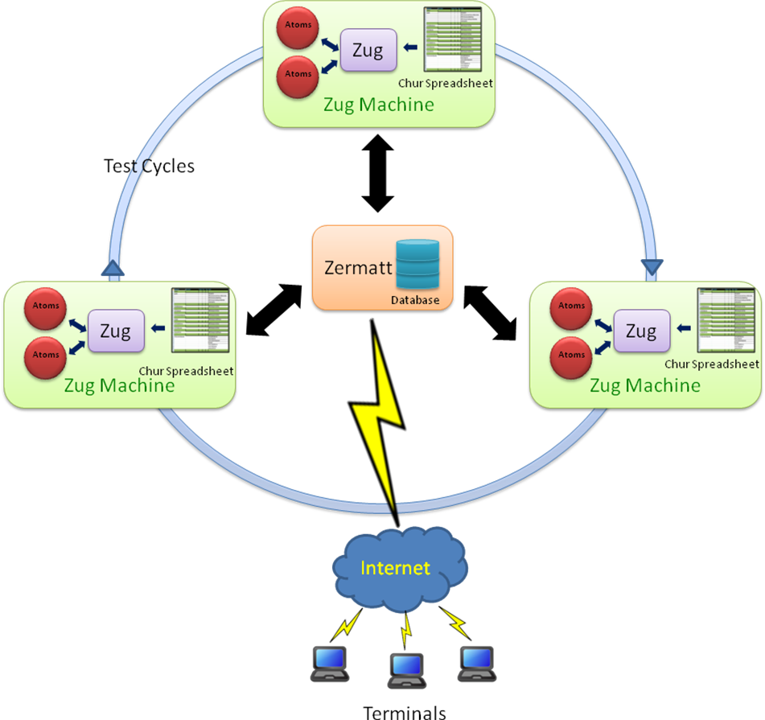

The atoms written in any scripting language are executed in Zug platform with the help of Chur spreadsheet in different Zug machines. After execution the results are stored in the data repository of Zermatt. The end-users can access the results in Zermatt through the internet at real time.

Running your first automated test

In this manual we are using an example for illustration where we open a document using an office application and close it automatically.
(If you are not using Zermatt or using the free version of Zug, then kindly ignore the following sections )

Preparing Zermatt for Zug

- Once the test plan is created in Zermatt, it can be used to store automated test results. The testplan_id of the test plan is one of the inputs required by Zug to file the results. The testplan_id can be found in Zermatt as shown in the figure below.

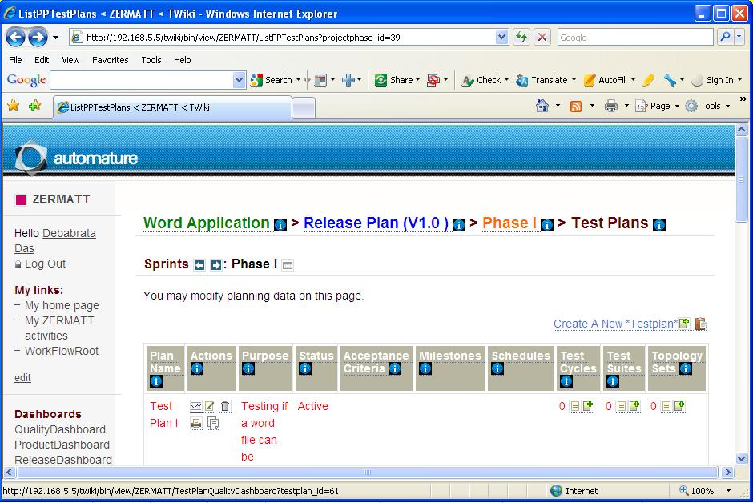
TestPlanID

- The topology sets are also needed to be written in Zermatt for integration with Zug. The topology sets has to be added to the list of topology sets of the test plan. The topology set written should have at least one topology. The topologyset_id is found as shown in the figure below in the status bar of List all Topology Sets for a chosen Test Plan.
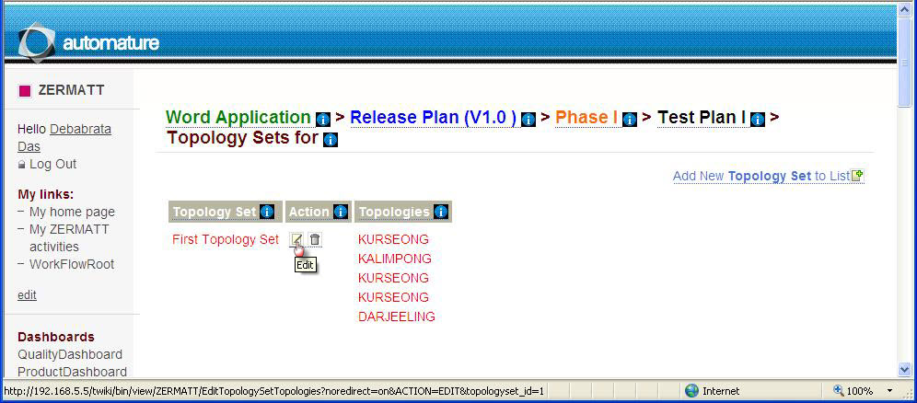
TOPOLOGYSET_ID
- We can see the participating topologies of the topology set in the Zermatt page List All Topology Sets:
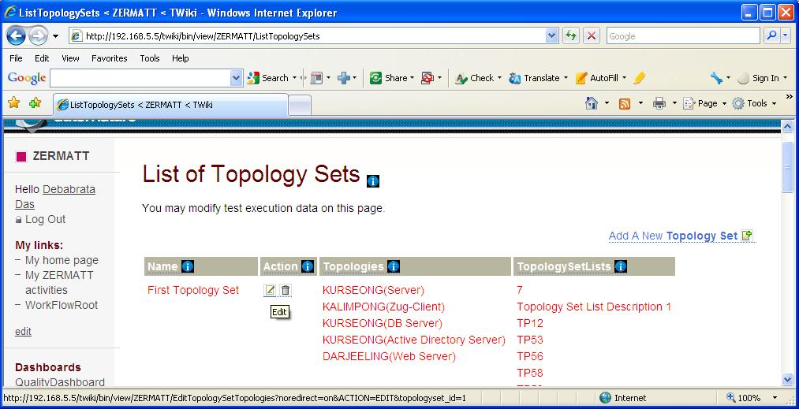
TOPOLOGYSET_ID
Roles

- The role of any one topology as shown in the above figure should match with the role stated in the Chur spreadsheet that is to be written later.
(For deeper understanding on CHUR, please refer to the Language Reference Manual of Chur)

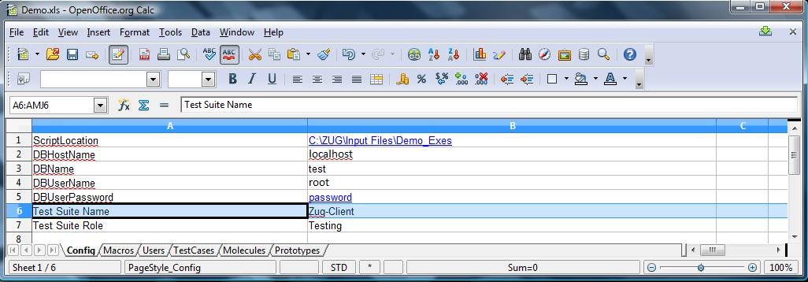
Roles

Managing Atoms
The atoms in Zug can be written in any scripting or programming language. In this manual we have created the atoms using AutoIT, a freeware BASIC-like scripting language designed for automating the Windows GUI and general scripting. For web based products, we have our own proprietary libraries named Zuoz. For more information regarding Zuoz kindly visit www.automature.com.
The demo atoms are written in AutoIT and stored in a folder inside the Input files folder of the Zug Kit.

Preparing Zug for Zermatt
Once the atoms are written, the Chur spread sheet is prepared. For more information on how to write a Chur file please refer to the Language Reference Manual of Chur.
The figure below shows the configuration page of Chur file for this test.
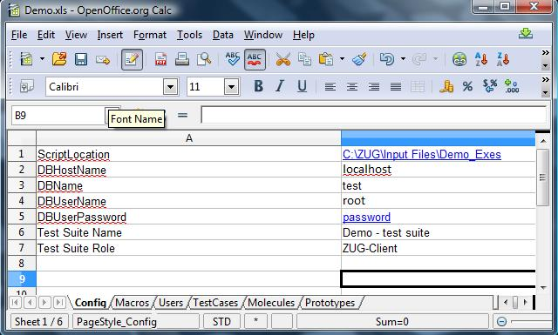
The Config page states the environmental information which is used by Zug to locate supporting programs and uploading results into the database.
- ScriptLocation states location of the folder where the Zug atoms are written for this test.
- DBHostName states the hostname for the database server. To keep the data repository of Zermatt in the Zug machine, localhost is given as input.
- DBName states the database name.
- DBUserName states the name of the user to do authentication to database.
- DBUserPassword states the password of the user required for SQL authentication.
- Test Suite Name states the name of the test suite which was stated in Zermatt.
- Test Suite Role states the role of the node where Test Suite will be executed.
The figure below shows the macros page of Chur file for this test.
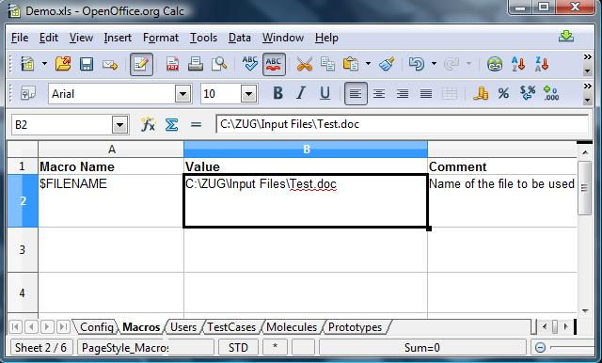
The macros allow the testcase designer to declare short names that can then be substituted in the testcase descriptions during execution. In this case, the path of the file Test.doc is given as input.

Executing the automated test
Time has come to execute the automated test in Zug. While executing, the test cycles will be incremented in Zermatt automatically. Before executing, the Zermatt page will look as shown in the figure below.

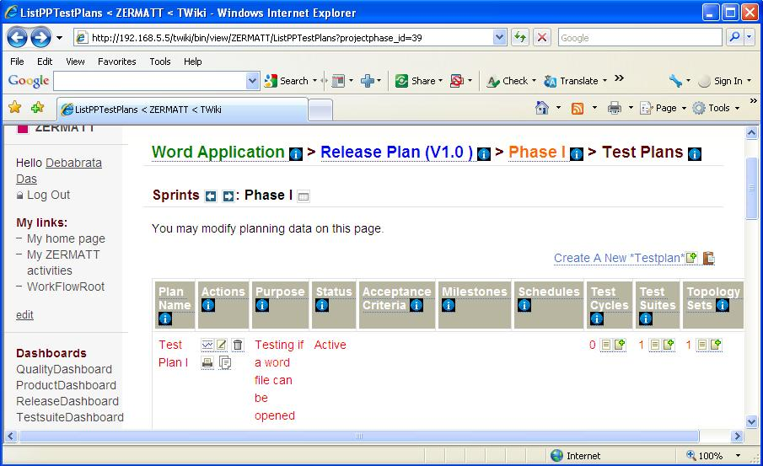
Demo Test Suite
Topology Set associated with this test plan
- Open the command prompt.

- Type runzug "C:\ZUG\Input Files\Demo.xls" -testplanid=61 -topologysetid=1 –verbose

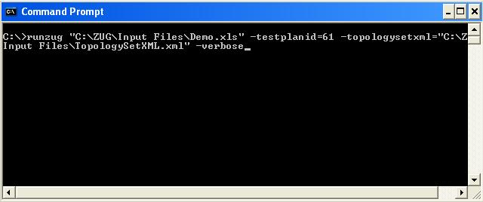

- The following screens will appear automatically. The automation starts....

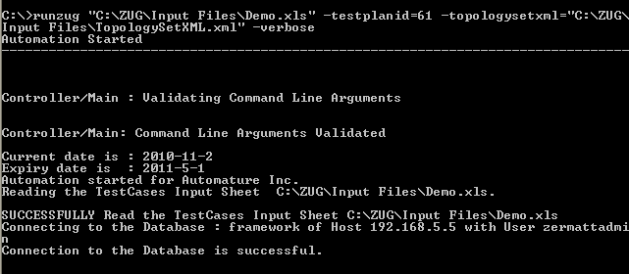

- The atom named STARTAPP.EXE is called to execute.
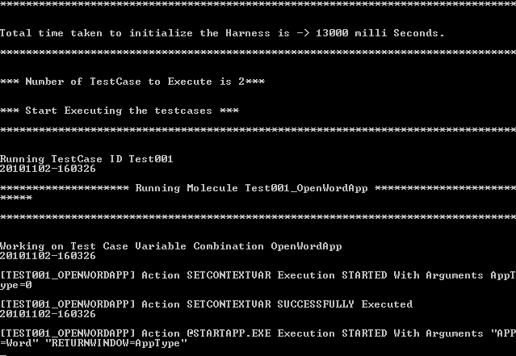

- The Word Application is opened.
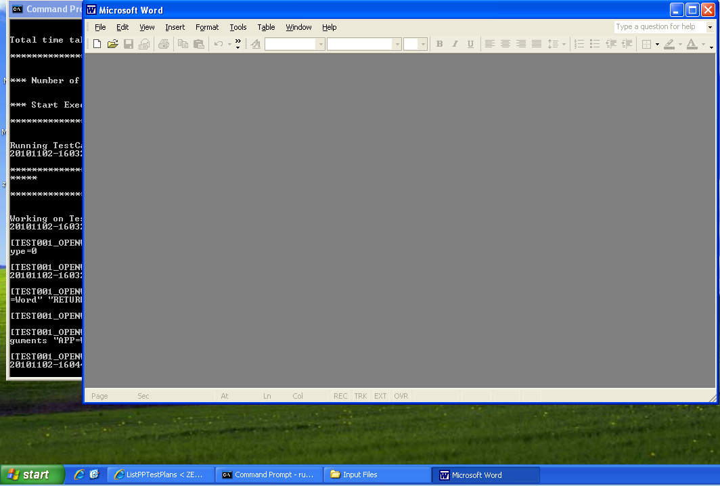

- The Word file is opened by executing the OPENFILE.EXE.

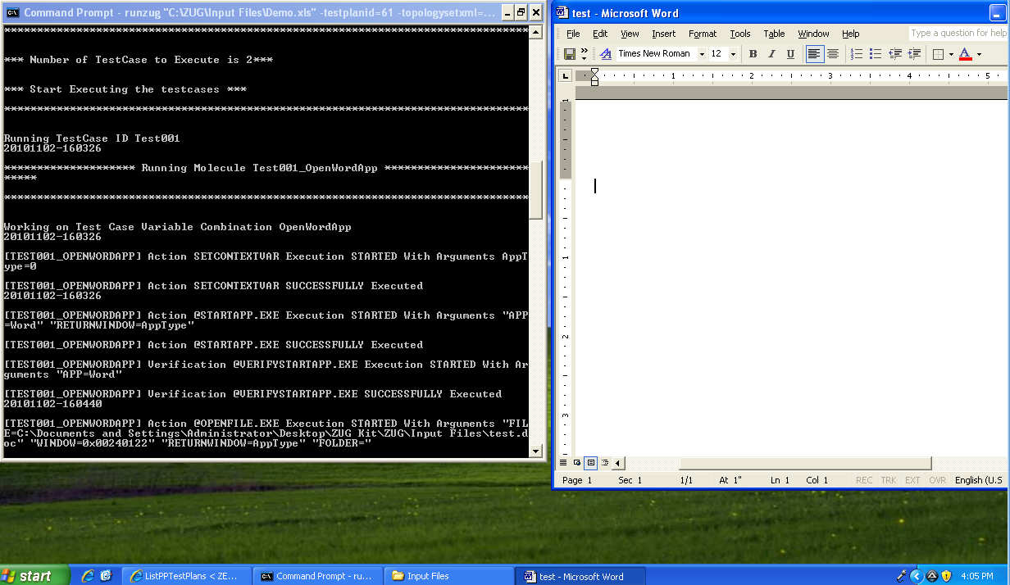

- After the Word file is opened, the CloseFile and the ExitFile executable files are called which closes the Word file and then exits from the Word application.

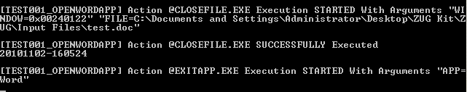

- The following screens appear on the command prompt which gives the result of the automated test.

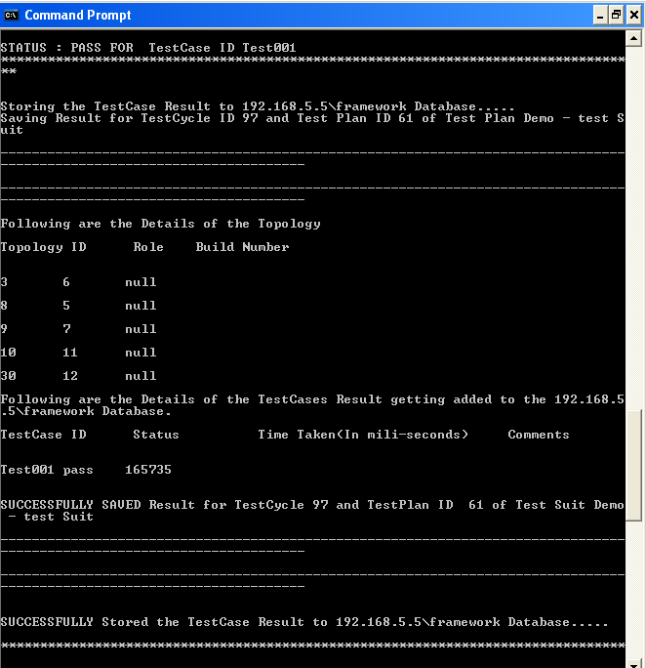
The detailed explanation will be stated in the following section -Viewing results in Zermatt.

Viewing results in Zermatt

- You will see that the test cycle is automatically increased to one. Refer to section Executing the automated test to see the previous value of test cycle. Now every time you run Zug, the value increments by itself.
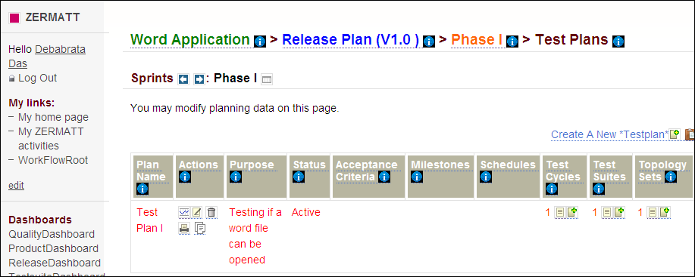

Interpreting the results
- Results in Command Prompt
The progress of the test-cases are displayed one after another. The specified Action and Verification Steps inside the test cases are executed and are shown at the same time in the command prompt. If any step fails then the exception message is displayed explaining the cause of failure.
At the end the brief result are shown in tabular form. The table has columns TestCase ID, status, Time Taken, Comments.
TestCase ID | The identifier of the test-cases which ran inside test suite
status | Pass/Fail
Time Taken (milli seconds) | Milliseconds taken to execute the test case
Comments | On failing, this states the exception message with the reason of failing

- Results in Log Files
Zug will generate four types of Logs. These logs will be created inside the AppData Folder (Application Data folder of windows OS) of logged in user.
All the Log File Name will be appended with a Date Time. For example Debug log will be named as 2008128-163637543-Debug.log (format is yyyymmdd-hhmmssmillisecond-debug) which means that this Debug Log is created on 8th December 2008 at 16 hours 36 minutes (last 5 are seconds and milli-seconds). Following is the description of the log files -
- "Result.log" - This log will contain the result of the test case, It will contain the status of the action(s) specified in the TestCase worksheet and also the appropriate error result if any error thrown during the test case series execution.
- "Debug.log"- This log will contain all the debug related messages.
- "Error.log"- This log will contain the error and warning messages if any error occurred during the execution.
- "Primitives.log" - This log will contain Logs from the Atoms during atom execution.

Viewing the test results from Zermatt:
To view the results in Zermatt, navigate to the page where the test plans are written. As said earlier, the test cycle is incremented from 0 to1.
View

Click on View and you will be able to see the following page. It states the time and the date of the initialization and completion of the test cycle.
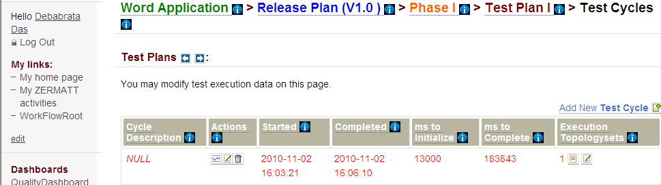

If you navigate into the topology set of that test plan, the test execution results are shown. It stated that the test has passed and also the duration and the date of the test execution.
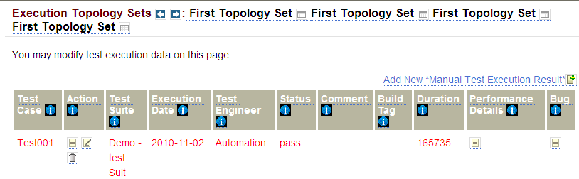

If you navigate to the Dashboards, the various kinds of results that might be possible is shown in various formats. For further information regarding dashboards, kindly refer to Zermatt User Manual.

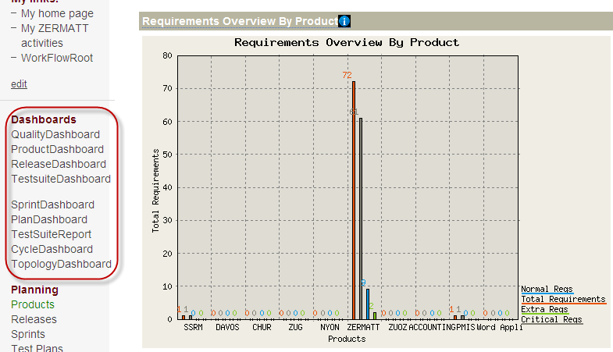

Archival the Log files
Zug supports log archiving. If Zermatt integration is used then Zug will archive the log. Zug will archive two types of logs:
- Tested product (like LMDC Client, Server) log files. Log file specified in Config sheet of Test design sheet. This is done by specifying ProductLogLocations in the Config sheet of Chur Test Suite.
- Zug created log files (Debug, Error, Result).These are the log files which are generated by the Zug during test plan execution.
Log Archival Setup
You can specify Archive Location in the Zermatt Configuration Page:

Troubleshooting

Debug Log
Zug generates different log file. Debug file stores messages which contain extensive contextual information. They are mostly used for problem diagnosis. In failures this file can be referred back to diagnose and investigate problems, exception. The step-by-step execution messages are appended during Zug automation. The file can be browsed through and

Primitive log
Zug executes Atoms. To learn how to write Atom please refer to Automature's Zuoz Programmer's Guide. Inside Atoms some logging command mechanism can be used to help future diagnosis of Atom execution. The Atom Logs are stored in Primitive Log File. In failures this file can be referred back to diagnose and correct Atoms

Database connection problem
In order to integrate test results with Zermatt there should be establishment of proper database connection. You can allow access to certain machines for the specified user connection. Do database user administration to add and modify users permission. Put proper connection details in preparing Zug for Zermatt. Refer Page 14 Preparing Zug for Zermatt
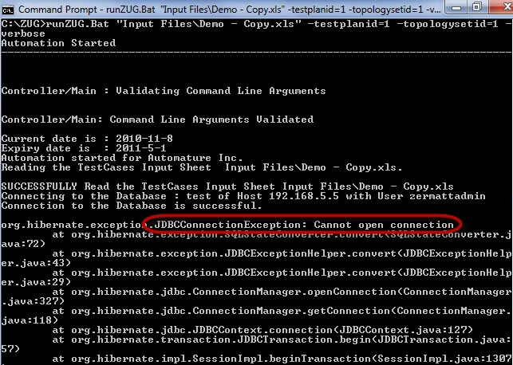

Unable to Archive Log Files
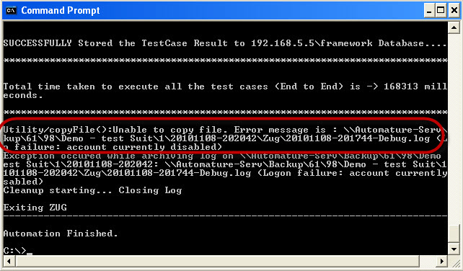
Archiving of Log files are done on location specified in Configuration (Refer page 23 Archival the Log files) Zug machine should be given proper write-permission for the location specified. An exception can occur as following:

License Expired
License can expire under the two following cases
- You are using an expired license. Each license has a certain validity period and it expires on a particular date as mentioned.
- You are using an improper license. The license may be incorrect or intended for other use.

Please contact downloads@automature.com to avail the premium version of Zug.
Please contact support@automature.com for any queries about Zug.

- For further problems visit ZUG Forum.

